Compiler design lab experiments
1
#include <stdio.h>
#include <string.h>

int main() {
char nonterm, prod[10], alpha[10], beta[10];
int i, j = 0, k = 0;

printf("Enter Non-Terminal (A): ");
scanf(" %c", &nonterm);

printf("Enter Production (A->Aα | β) without spaces: ");
scanf("%s", prod);

// prod example: AAb|c meaning A -> A b | c

// Separate alpha (Aα) and beta (β)
for (i = 1; prod[i] != '\0'; i++) {
if (prod[i] == nonterm) { // Aα case
i++;
while (prod[i] != '|' && prod[i] != '\0')
alpha[k++] = prod[i++];
}
if (prod[i] == '|') { // β case
i++;
while (prod[i] != '\0')
beta[j++] = prod[i++];
}
}

alpha[k] = '\0';
beta[j] = '\0';

printf("\nAfter Eliminating Left Recursion:\n");
printf("%c -> %s%c'\n", nonterm, beta, nonterm);
printf("%c' -> %s%c' | ε\n", nonterm, alpha, nonterm);

return 0;
}
Output
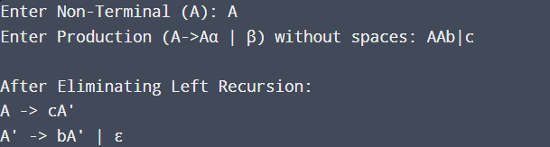

2
#include <stdio.h>
#include <string.h>

struct Symbol {
char name[20];
char type[10];
int address;
} table[50];

int count = 0;

void insert() {
printf("\nEnter symbol name: ");
scanf("%s", table[count].name);

printf("Enter type: ");
scanf("%s", table[count].type);

table[count].address = count + 100; // simple address
count++;

printf("Symbol inserted.\n");
}

void search() {
char name[20];
printf("\nEnter symbol name to search: ");
scanf("%s", name);

for (int i = 0; i < count; i++) {
if (strcmp(table[i].name, name) == 0) {
printf("Found: %s %s %d\n", table[i].name, table[i].type, table[i].address);
return;
}
}
printf("Symbol not found.\n");
}

void display() {
printf("\nSymbol Table:\n");
printf("Name\tType\tAddress\n");
for (int i = 0; i < count; i++) {
printf("%s\t%s\t%d\n", table[i].name, table[i].type, table[i].address);
}
}

int main() {
int choice;

while (1) {
printf("\n1. Insert\n2. Search\n3. Display\n4. Exit\nEnter choice: ");
scanf("%d", &choice);

switch (choice) {
case 1: insert(); break;
case 2: search(); break;
case 3: display(); break;
case 4: return 0;
default: printf("Invalid choice.\n");
}
}
}
Output
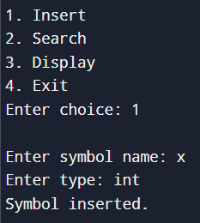

3 #include <stdio.h>
#include <string.h>

int main() {
char nonterm;
char prod[50];
char common[20], p1[20], p2[20];
int i = 0, j = 0, k = 0;

printf("Enter Non-Terminal: ");
scanf(" %c", &nonterm);

printf("Enter production (ex: A->abz|abx) without spaces: ");
scanf("%s", prod);

// Skip "A->"
i = 3;

// Extract first production p1
while (prod[i] != '|' && prod[i] != '\0')
p1[j++] = prod[i++];

p1[j] = '\0';
i++; // skip '|'

// Extract second production p2
j = 0;
while (prod[i] != '\0')
p2[j++] = prod[i++];

p2[j] = '\0';

// Find common prefix
while (p1[k] == p2[k]) {
common[k] = p1[k];
k++;
}

common[k] = '\0';

printf("\nAfter Left Factoring:\n");
printf("%c -> %s%c'\n", nonterm, common, nonterm);
printf("%c' -> %s | %s\n", nonterm, p1 + k, p2 + k);

return 0;
}
Output

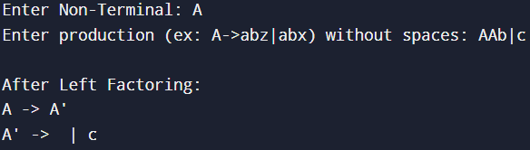

4
#include <stdio.h>
#include <string.h>
#include <ctype.h>

char input[100];
int pos = 0;

// Forward declarations
void E();
void Eprime();
void T();
void Tprime();
void F();

void error() {
printf("Error at position %d near '%c'\n", pos, input[pos]);
}

int match(char ch) {
if (input[pos] == ch) {
pos++;
return 1;
}
return 0;
}

// E → T E'
void E() {
T();
Eprime();
}

// E' → + T E' | ε
void Eprime() {
if (input[pos] == '+') {
match('+');
T();
Eprime();
}
// else epsilon (do nothing)
}

// T → F T'
void T() {
F();
Tprime();
}

// T' → * F T' | ε
void Tprime() {
if (input[pos] == '*') {
match('*');
F();
Tprime();
}
// else epsilon (do nothing)
}

// F → ( E ) | id
void F() {
if (match('(')) {
E();
if (!match(')')) {
error();
}
} else if (isalpha(input[pos])) { // id
pos++;
} else {
error();
}
}

int main() {
printf("Enter expression: ");
scanf("%s", input);

pos = 0;
E();

if (input[pos] == '\0') {
printf("Input string is VALID\n");
} else {
printf("Input string is INVALID\n");
}

return 0;
}
Output
